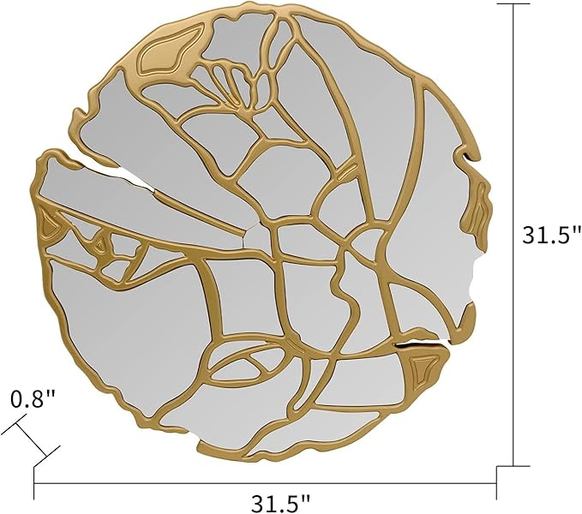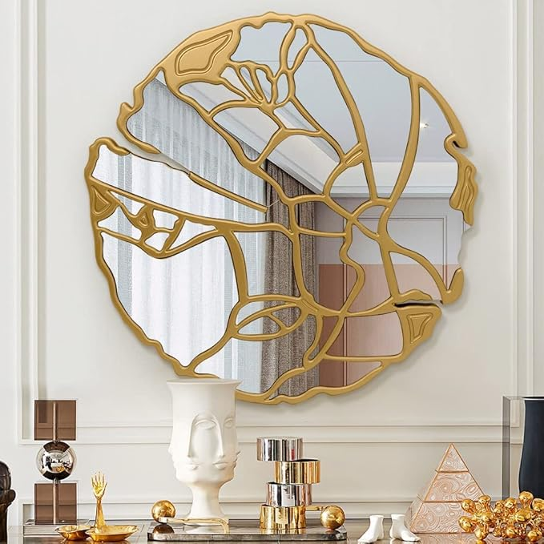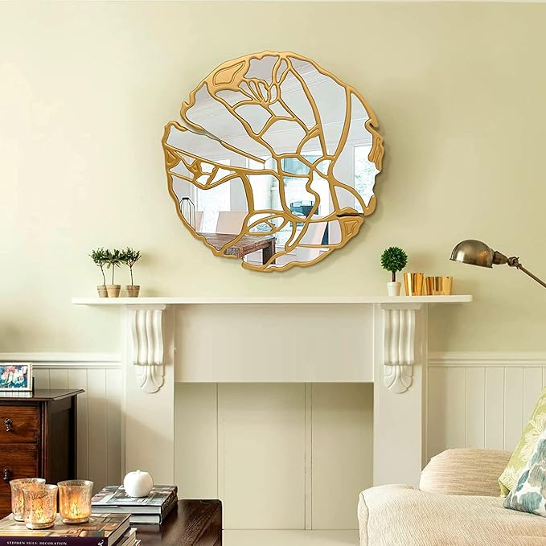

Pregaspor Round Wall Mirrors Decorative, 31.5'' Irregular Frame Gold Mirror for Wall Decor, Large Wall Mirror for Living Room, Entryway, Bedroom

**PRODUCT DESCRIPTION:**

|  |  |
| --- | --- |
| Brand | Pregaspor |
| Room Type | Living Room, Home Office, Dining Room |
| Shape | Round |
| Product Dimensions | 31.5"L x 31.5"W |
| Frame Material | Engineered Wood |

**About this item**

* 【Gorgeous Design】 Our decorative wall mirror has a unique design, the irregular golden frame forms a gorgeous shape, suitable for any modern style decoration or simple setting, making the indoor space greater and brighter.
* 【Premium Material】 This gold wall mirror is made of high - quality MDF and silver mirror. The frame is strong and long-lasting. Paint on the frame is environment - friendly and safe. The clear image of the mirrors for wall can provide the best visual experience.
* 【Wide Application】 The size of this large mirror is 31.5*31.5*0.8inch, which can be widely used in living room, corridor, bedroom, shop, office, decoration room, adding a warm feeling to the living environment.
* 【Easy to Install】 There are 2 easy-to-rotate buckles fixed on the back of the gold mirrors for wall, make sure that it can be hang on the wall firmly. we recommend 2 peoples to install it because of the weight.
* 【Professional Packaging】 The large round mirror has been packed with professional packaging. Our strong packaging ensures that the product is in good condition. If it has any defects, please contact us. We will serve you wholeheartedly within 24 hours.